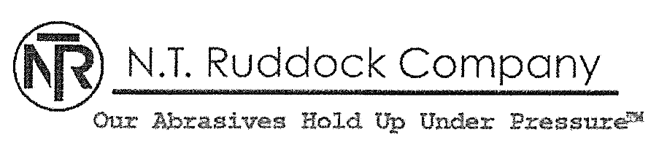

Air Blasting Guidelines
(Approximate)

Profile | Grit
1 mil profile | 100 grit aluminum oxide
1.5 mil profile | 54-60 grit aluminum oxide
2 mil profile | 36-54 aluminum oxide
2.5 mil profile | 36-54 grit aluminum oxide
3 mil profile | 16-24 grit aluminum oxide
4 mil profile | 12-16 grit aluminum oxide

